**Practical No.3**

Synchronization:

1)Write a program to give a solution to the Bounded buffer problem.

2)Write a program to give a solution to the readers–writers problem

Input:-

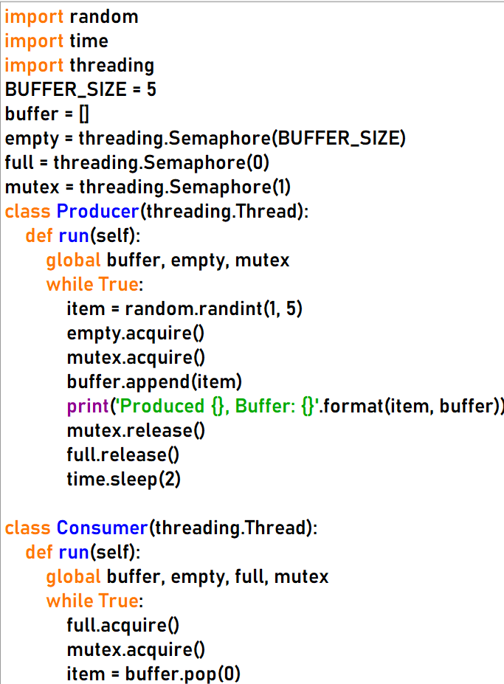

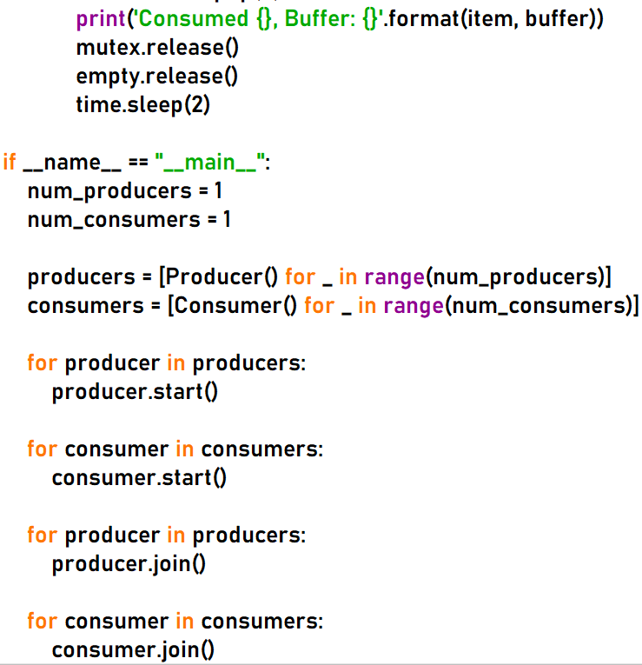

Output:-

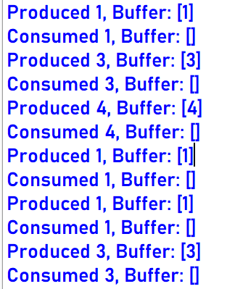

* Write a program to give a solution to the readers–writers problem

Input:-

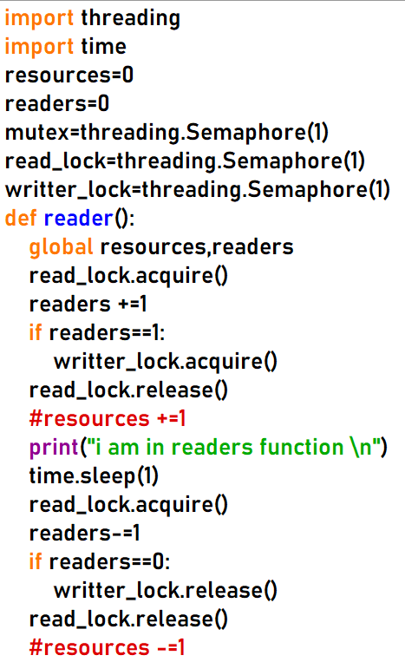

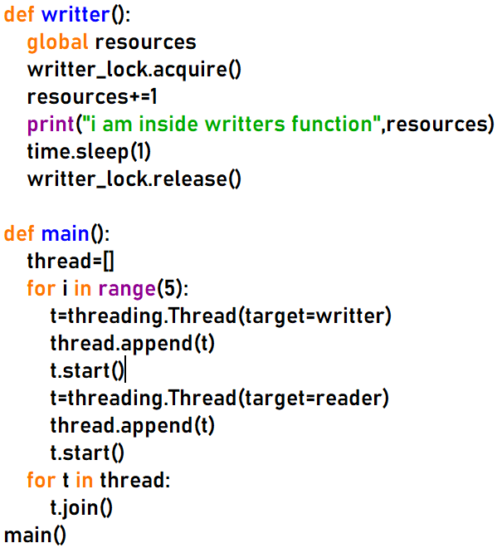

Output:-

